# Brachytherapy Treatment Planning and Navigation System – User Manual v1.3a FOR BETA VERSION ONLY

**Table of Contents**

1 Introduction 4

1.1 Purpose 4

1.2 Highlighted Features 4

2 Installation 5

3 Usage 6

Workflow pipeline 6

3.1 Basic Controls 7

3.2 Image Preprocessing 8

3.3 Image Segmentation 10

3.4 Treatment planning 12

3.5 Post-surgical Analysis 20

4 Known Issues 23

5 Credits 24

**Table of Figures**

Figure 1 Workflow Diagram 6

Figure 2 Toolbar tooltips 1 7

Figure 3 Toolbar tooltips 2 7

Figure 4 3D Navigation 8

Figure 5 Function tab options - Image Preprocessing 8

Figure 6 Registration properties 9

Figure 7 Image fusion properties 9

Figure 8 Image fusion describe 10

Figure 9 Export images 10

Figure 10 Function tab options - Image Segmentation 11

Figure 11 Segmentation properties 11

Figure 12 Function tab options - Treatment Planning 12

Figure 13 Set Entry Point 12

Figure 14 Adjust seed properties 13

Figure 15 Generate Guide Tube 13

Figure 16 Guide tube control widget 14

Figure 17 Moving Seeds 14

Figure 18 Generate Planned Dose Map & Contour 15

Figure 19 Dosemap with contour 15

Figure 20 Calculate Planned DVH 16

Figure 21 DVH illustration 16

Figure 22 Function tab options - Cast Building 17

Figure 23 Build Cast Properties 17

Figure 24 Cast Mesh Product 17

Figure 25 Export Mesh 18

Figure 26 Advance marker options 18

Figure 27 Holes punching 19

Figure 28 Marked Cast Mesh 19

Figure 29 Post-Surgical Analysis Panel 20

Figure 30 Seed 3D mesh 21

Figure 31 Auto locate Seeds 21

Figure 32 Seed Adjusting mode 22

Figure 33 Selecting Seed 22

## Introduction

### Purpose

The purpose of this document is to instruct user with the basic usage of the Brachytherapy Treatment Planning and Navigation System (BTPNS) in details. Through reading this document, user will be able to make use of BTPNS for pre-surgical planning, intra-surgical navigation and post-surgical verification.

### Highlighted Features

The BTPNS highlights the following features:

1. All-in-one pipeline system architecture.
2. Easy-to-use and intuitive interface.
3. Unrestricted insertion path planner.
4. 3D-visualization of planning paths and segmented label.
5. Automatic generation of 3D-printable surgical guide.

## Installation

Follow the instruction to install the software:

1. Unpack the zip/rar file.
2. Double click the script file “Setup.vbs”.
3. Press “Install” when prompted with installation of Microsoft Visual C++ redistributable. Finish the rest of the installation as instructed.
4. Press “Run” when prompted with system security message.
5. Installation is completed when you see “Brachytherapy-TPNS” short cut appears at the root directory of installation.

## Usage

### Workflow pipeline

The BTPNS adopt a pipeline fashion for each patient cases as shown in Figure 1.

Figure 1 Workflow Diagram

### Basic Controls

BTPNS consist of an Image view with traditional controls grouped in four modes, namely “View”, “Image Level”, “Move” and “Draw” modes.

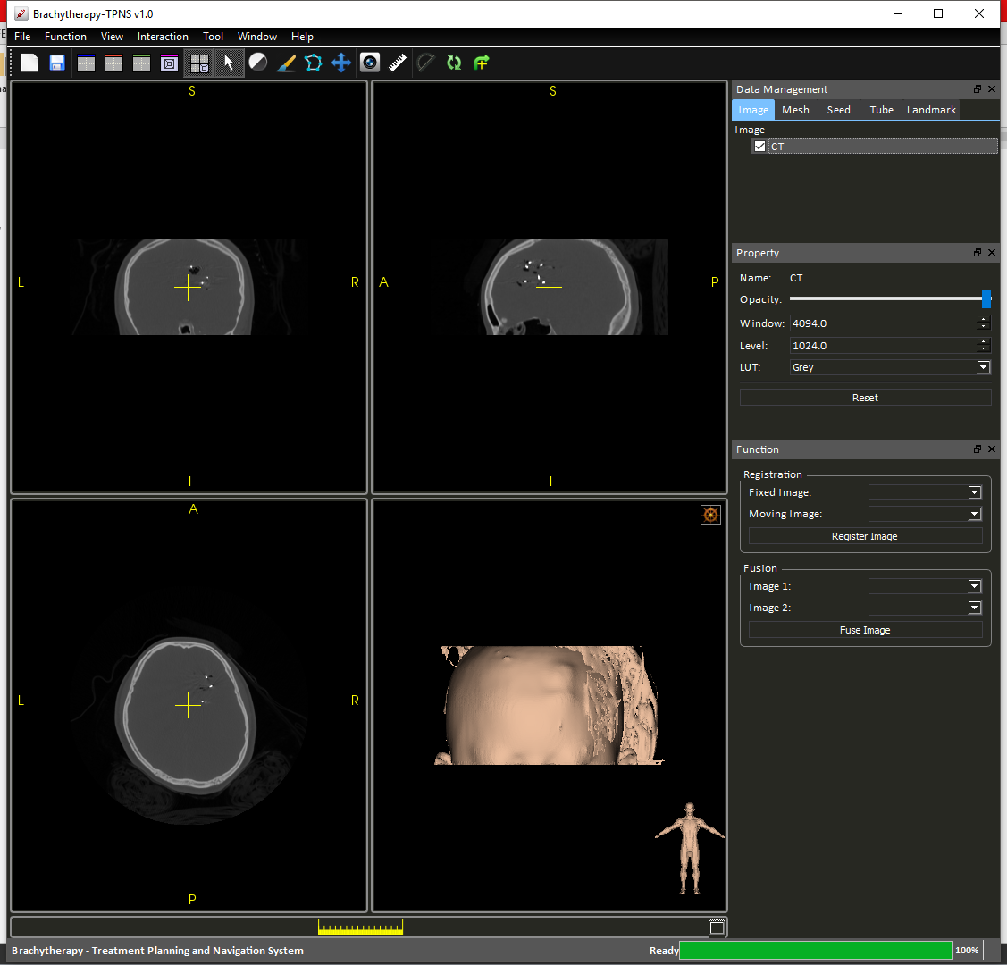

View

Image Level

Draw

Move

UI Layout

Figure 2 Toolbar tooltips 1

|  |  |
| --- | --- |
| **Modes** | **Operations** |
| View | * Left click to select slices location * Hold right click to zoom * Hold middle click to move camera |
| Image Level | * Hold left click to control the contrast and brightness of images. |
| Draw | * Hold left click to draw labels on label map. * Hold right click to erase label from label map |
| Move | * Hold left click to rotate selected image. * Hold middle click to translate selected image. |

The UI Layout buttons changes the layout to Sagittal/Coronal/Axial/3D/4-up respectively.

There are also additional widgets for user’s convinience.



Screen Capture

Reset View Plane

Ruler

Protractor

Center Camera

Figure 3 Toolbar tooltips 2

|  |  |
| --- | --- |
| **Widgets** | **Functions** |
| Screen Capture | Capture the scene on screen. |
| Ruler | Measuring distance. |
| Protractor | Measure angles. |
| Center Camera | Resets the camera and center the camera with respect to all the loaded images. |
| Reset View Plane | Resets the view plane normal to follow Cartesian x, y and z. |

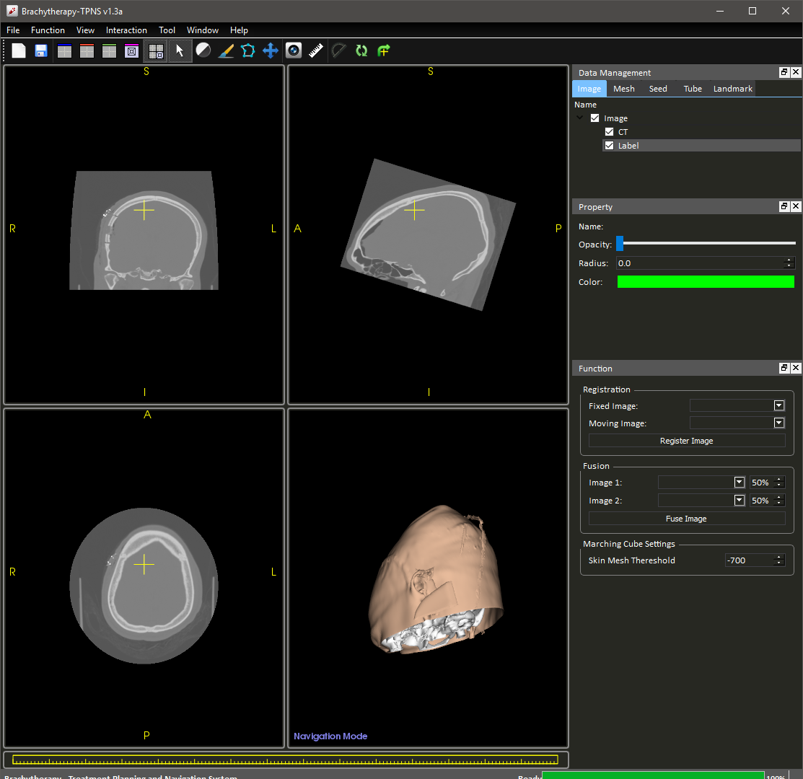

Figure 4 3D Navigation

In the lower left corner of the 3D view port, a string of characters will indicate which mode of interaction users are in.

|  |  |
| --- | --- |
| **Modes** | **Functions** |
| Navigation Mode | Left click to control the anchor point at which 2D slices are cut.  Draw to control the camera view angles. |
| Seed Picking Mode | Interacts with 3D seeds landmarks. (More detail in 3.5) |

### Image Preprocessing

The image preprocessing step can be performed by selecting “Image Preprocessing” option under the “Function” tab (Figure 5).

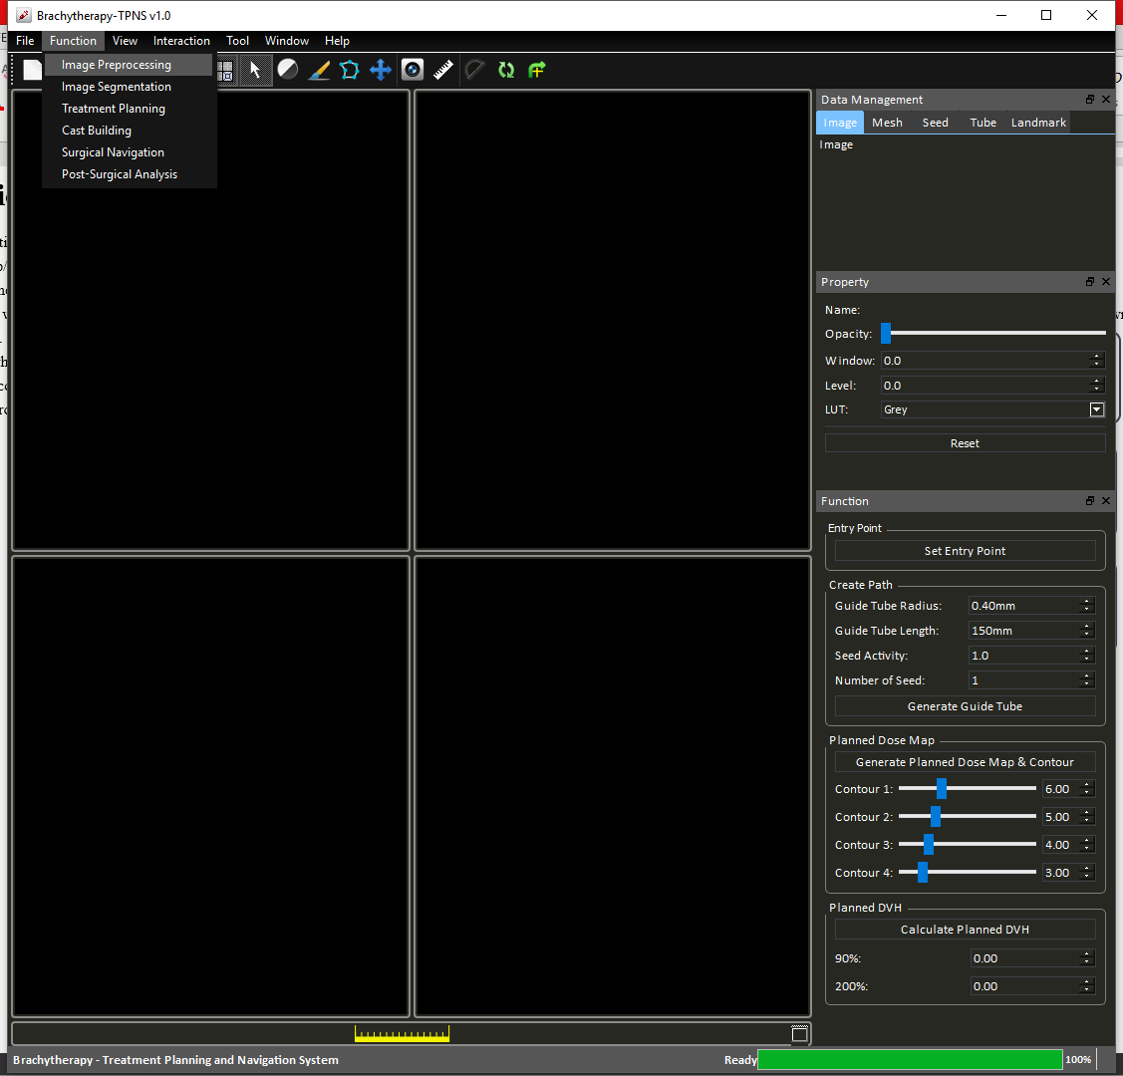

Figure 5 Function tab options - Image Preprocessing

During this step, registration and image fusion can be performed optionally.

#### Registration

To register the image, user can follow these steps:

1. Manually align the images roughly.
2. Choose fix image and moving image in the panel at the right-hand-side (Figure 6).

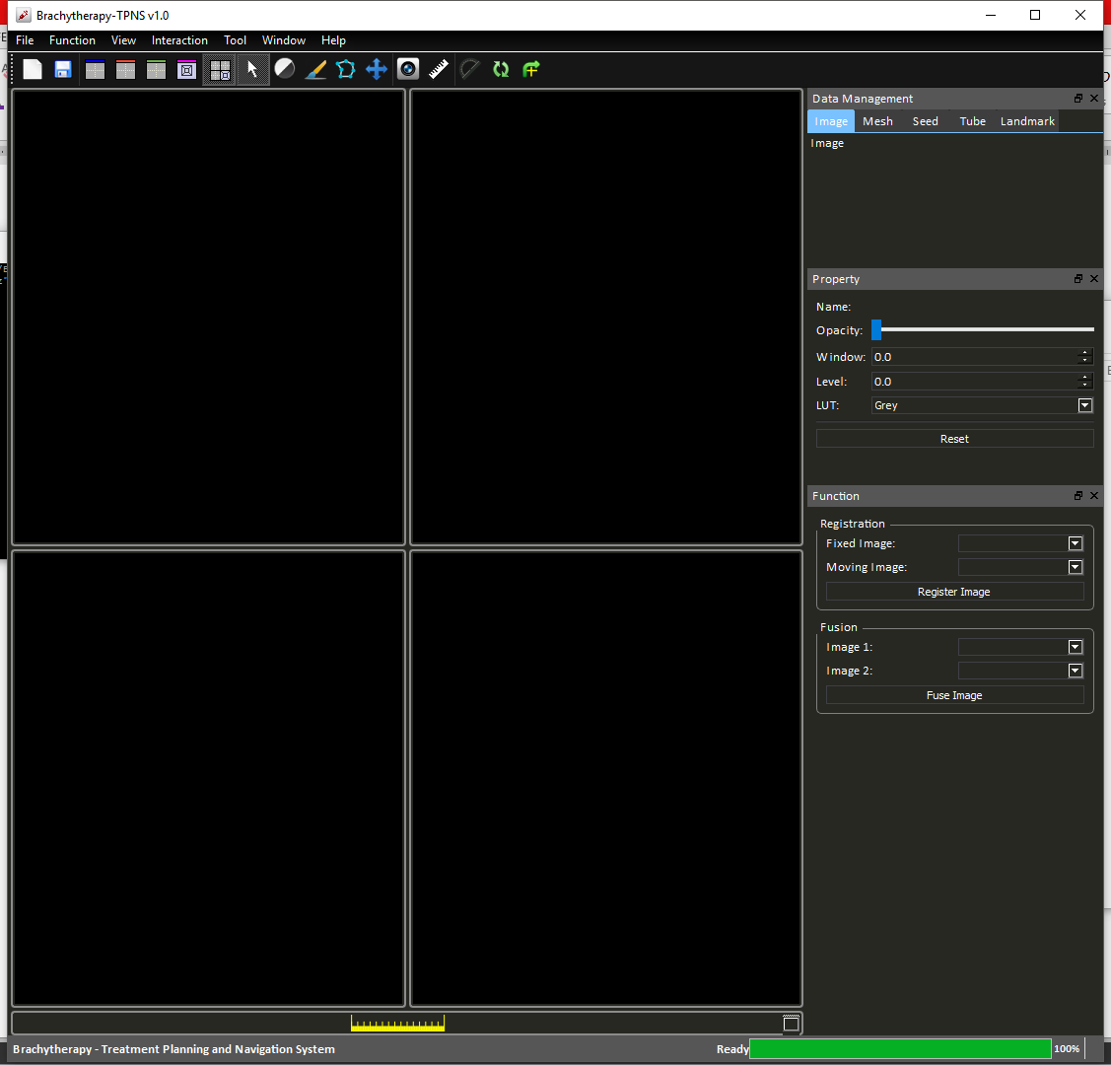

Figure 6 Registration properties

1. Press “Register Image”.

This process may take 5-20 seconds depend on the quality of the initial alignment. If the result is not satisfactory, user can perform a series of registrations by repeating the upper steps.

#### Image Fusion and Exporting Images

To fuse two images into one weight sum image, user can follow these steps:

1. Select images to be fused.



Figure 7 Image fusion properties

1. Press “Fuse Image”

A new image data will be created as the 50-50 weighted sum of the two selected images (Figure 8). The weight constant can be adjusted by changing the percentage value at the right hand side.

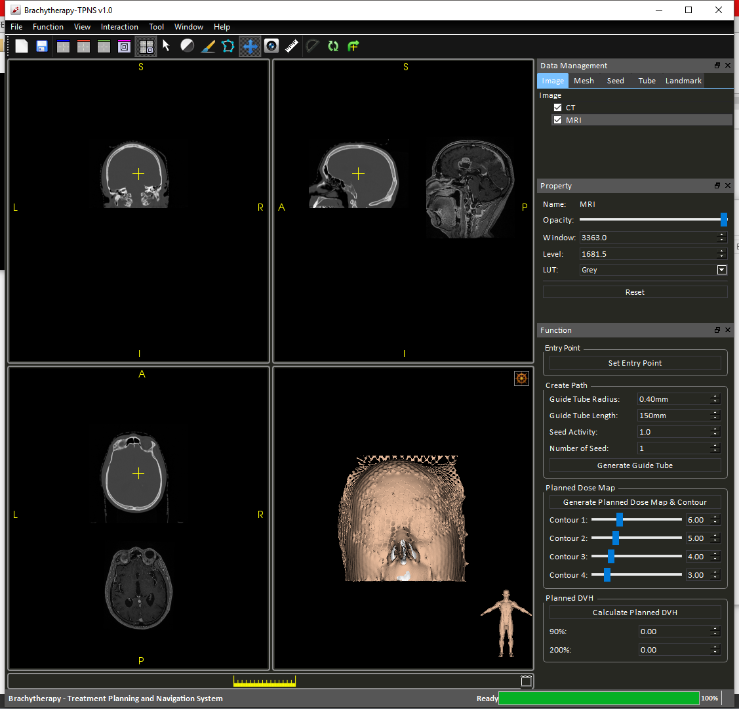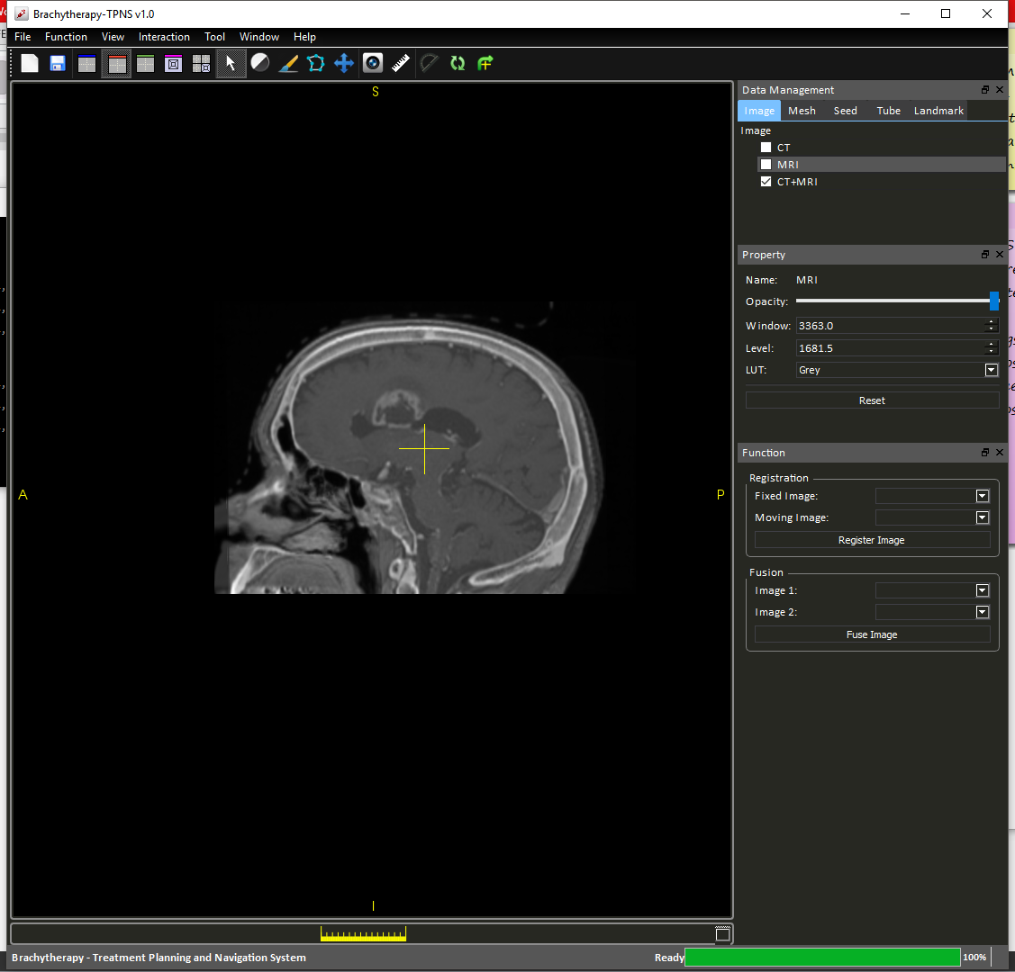

Figure 8 Image fusion describe

To export the fused image, right click on the image “CT+MRI” on the “Data Management Panel” and select “Export as DICOM/NIFTI”.

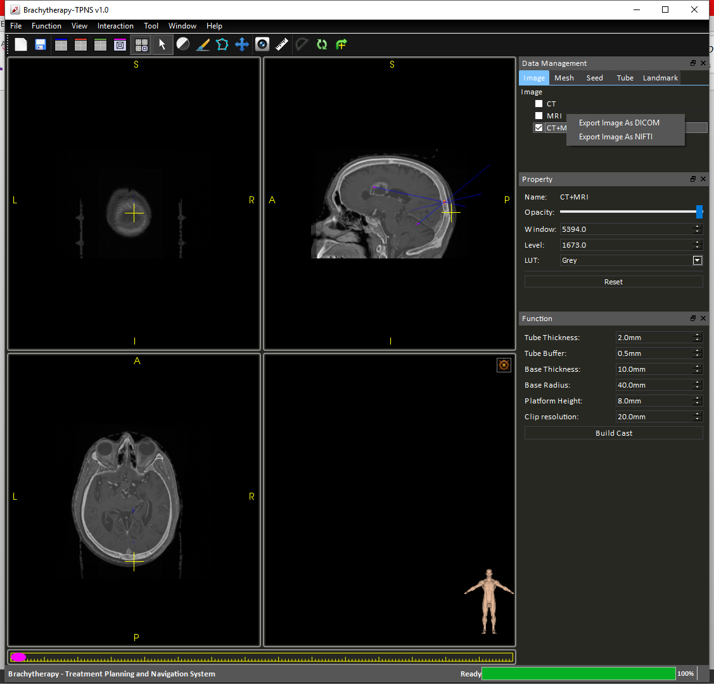

Figure 9 Export images

#### Mesh Marching Cube Settings

Cast building in latter steps uses the skin mesh as the basis. To guarantee a good quality surgical guide, you should adjust the marching cube threshold and examine the mesh before proceeding. User can achieve this by adjusting the following parameter in the right-hand-side panel (Figure 10):

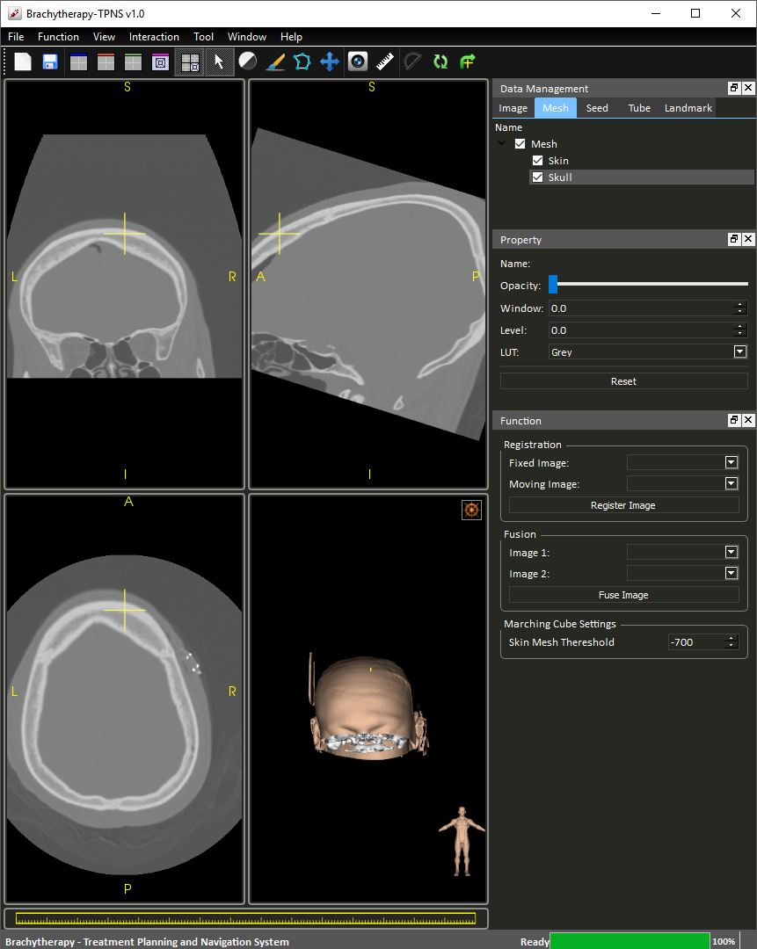

Figure 10 Marching Cube Setting

### Image Segmentation

To carry out segmentation, a label map has to be created if not pre-loaded. This can be done by clicking the “Image Segmentation” as in

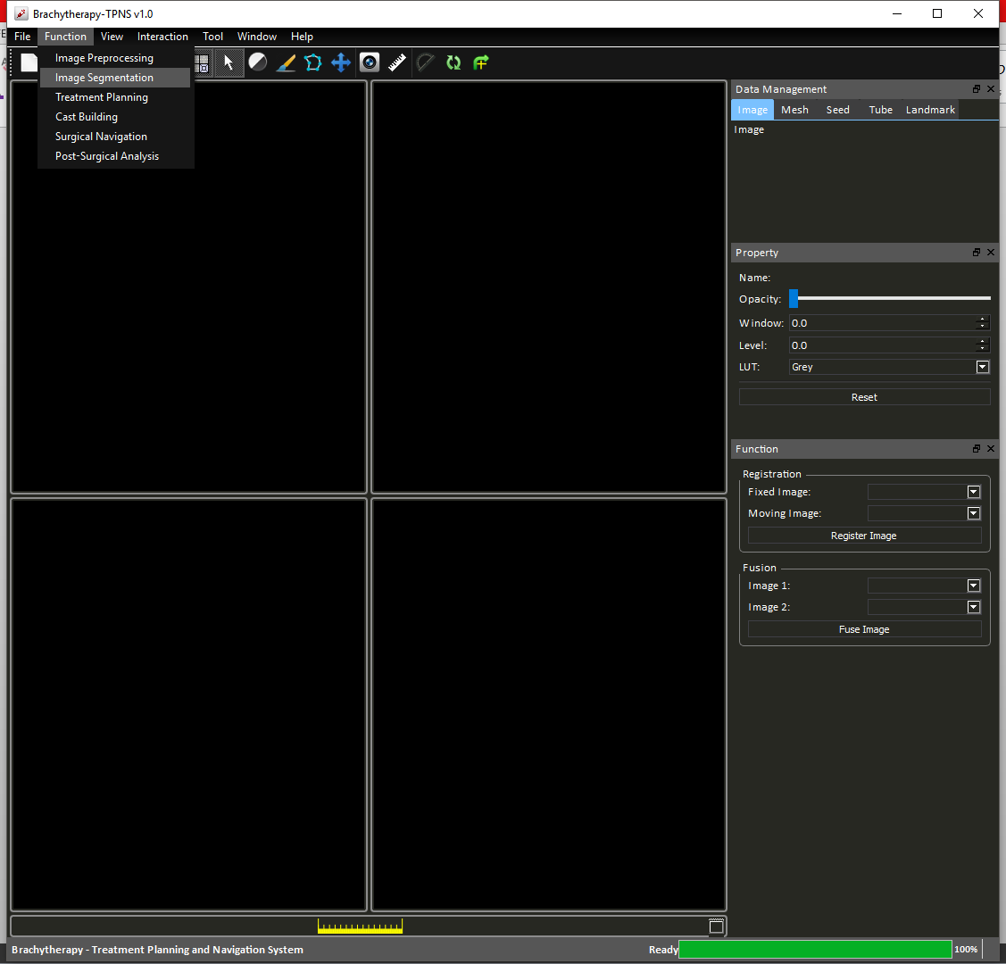

Figure 11 Function tab options - Image Segmentation

A property tab will appear at the right of the user interface for adjusting brush properties.

#### Drawing

Press the painter to activate “Draw” mode, right click on the targeted region to draw labels and left click to erase the labels. Note that when “Draw” mode is activate, the direction of the image is temporally cleared. It is also recommended that user first fuse the images before segmentation due to restriction of reslicer.

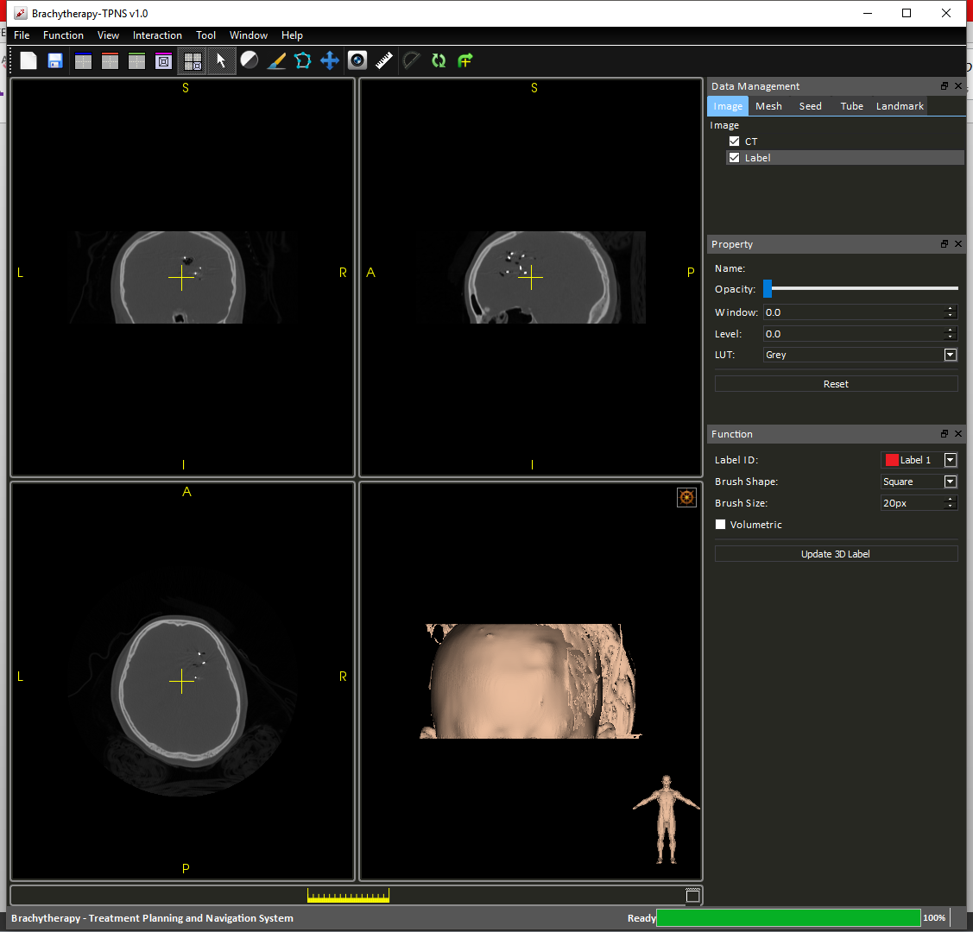

Figure 12 Segmentation properties

Brush shape refers to the shape of the drawn label, currently user can select between square and circle (Figure 12). Brush size refers to the pixel length of the sides/diameter of the drawn label.

### Treatment planning

Treatment planning is initiated by selecting “Treatment Planning” option under “Functions tab (Figure 13).

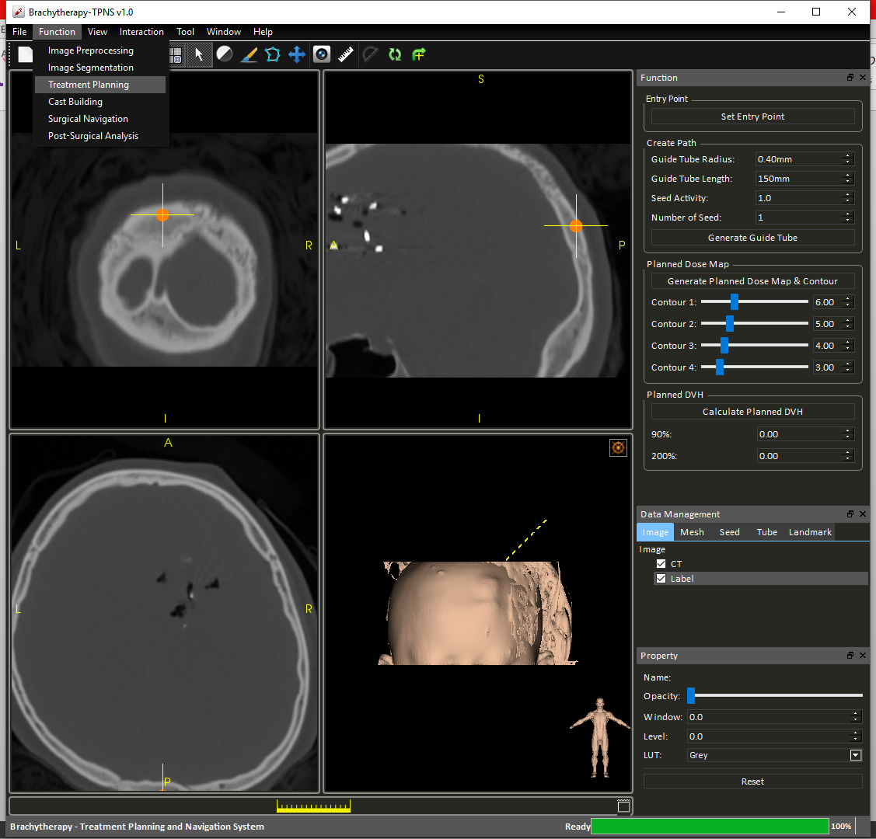

Figure 13 Function tab options - Treatment Planning

#### Placing guide tubes and seeds

Seed placing planning typically involve three steps:

**Step 1**: Select entry point in “View” mode, press “Set Entry Point”.

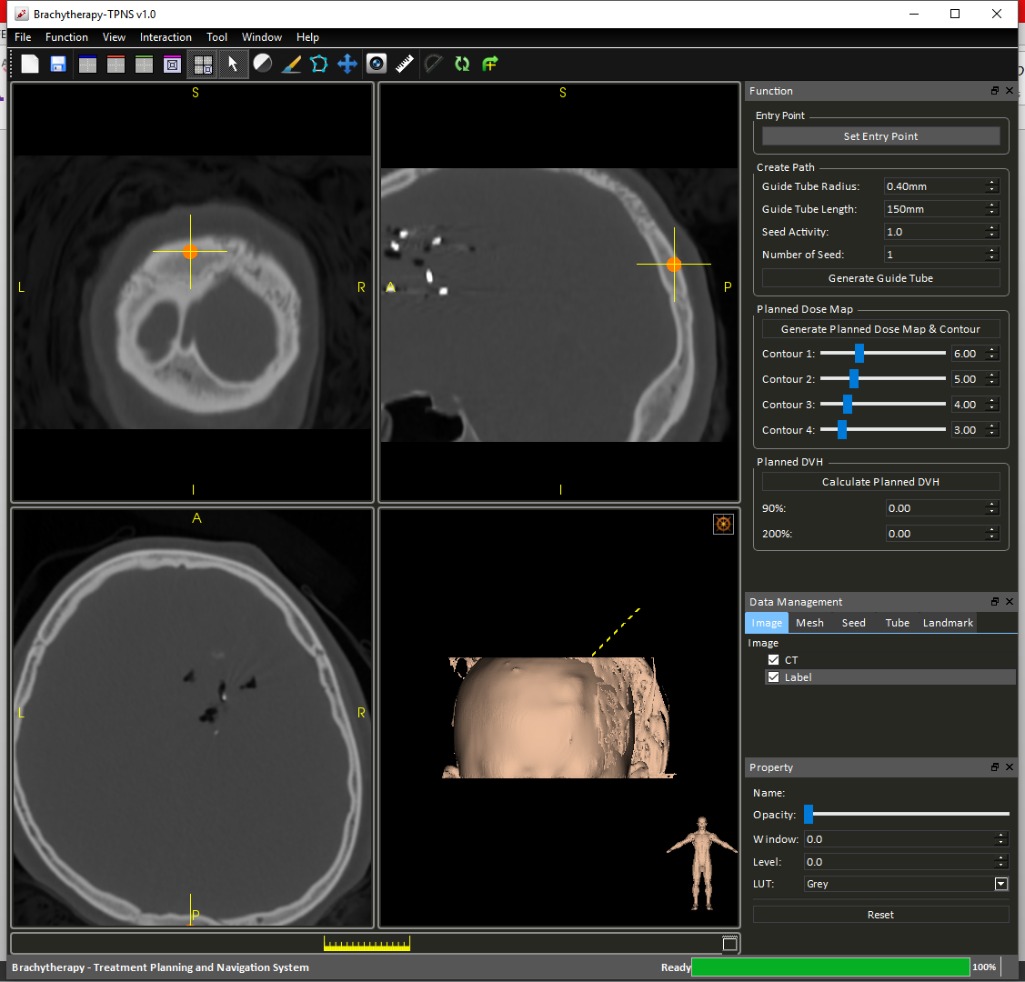

Figure 14 Set Entry Point

**Step 2**: Modify seeds properties and number of seeds.

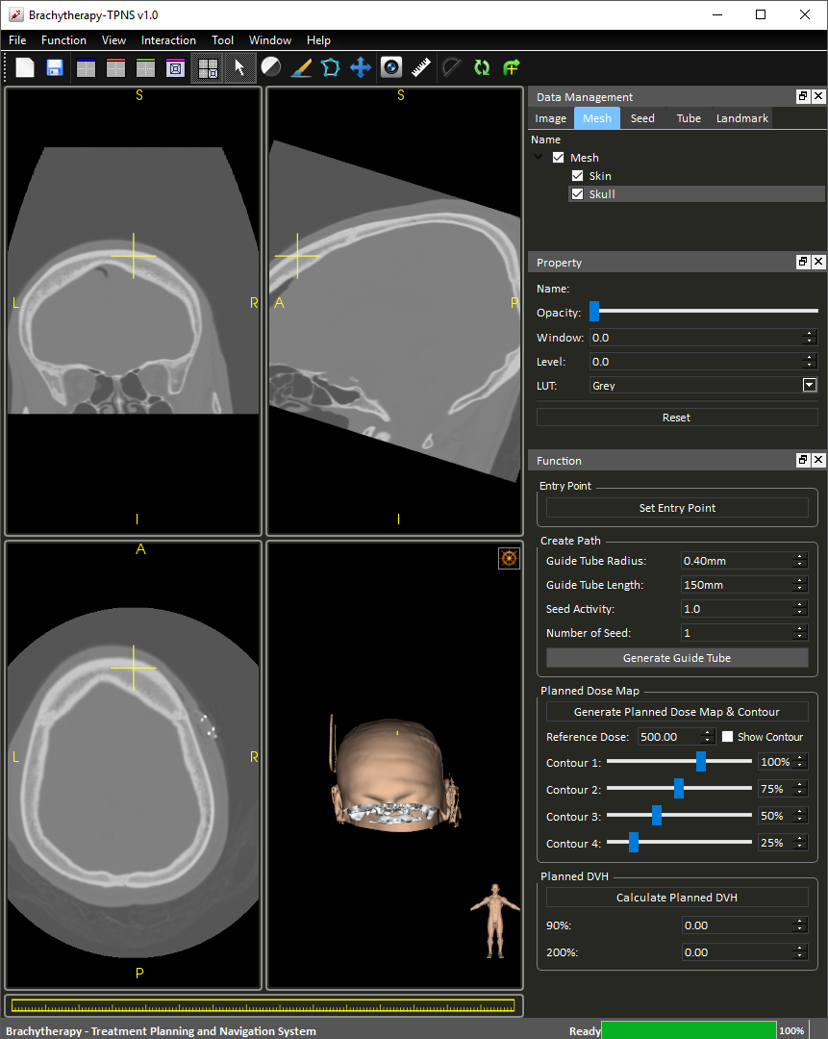

Figure 15 Adjust seed properties

**Step 3**: Select end point of insertion tool, press “Generate Guide Tube”.

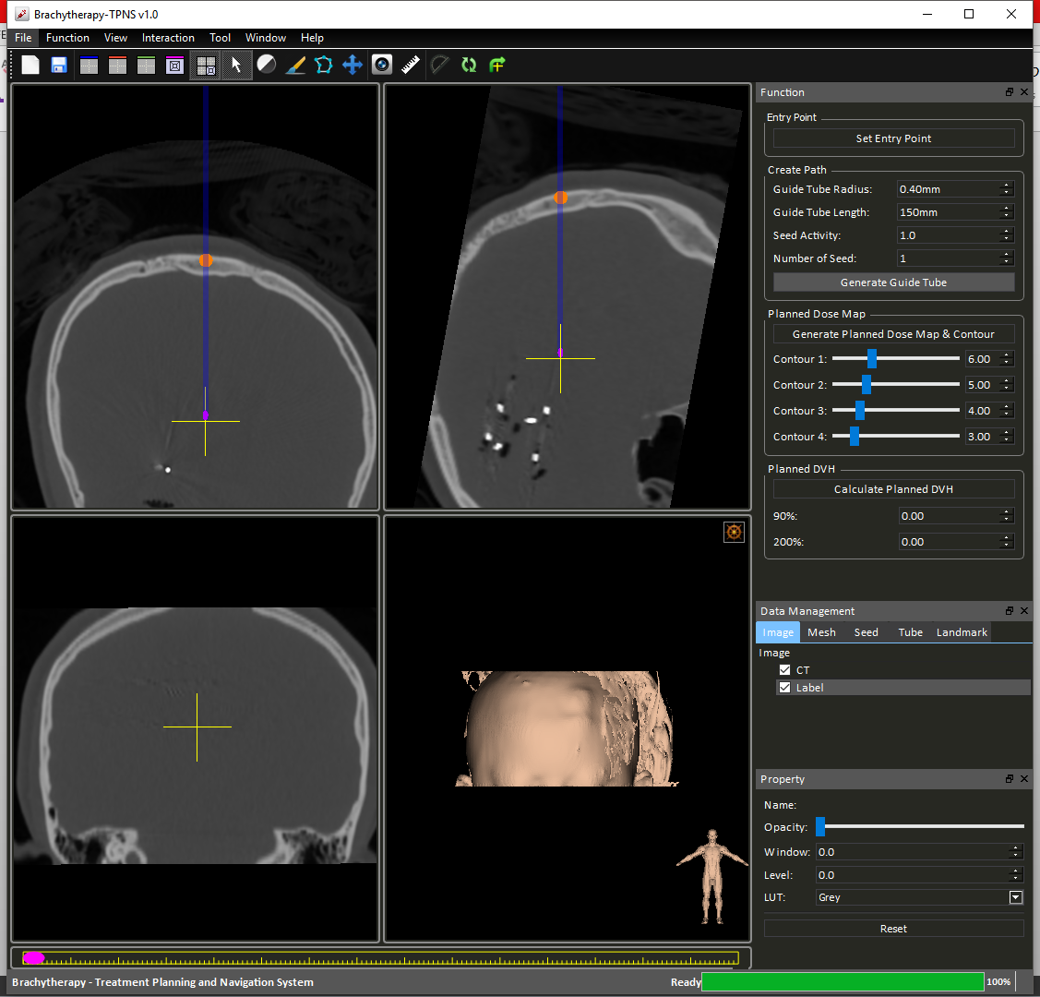

Figure 16 Generate Guide Tube

Once the guide tube is placed, the camera will automatically provide the oblique (Figure 16) view of the tube based on its orientation. User can resume normal view by pressing the right-most “Reset View Plane” button to reset the view plane to follow the x-y-z orientation.

A widget (Figure 17) at the bottom of the view ports allows operations including moving seeds position within its guide tubes, add/remove seeds and removing the tube.

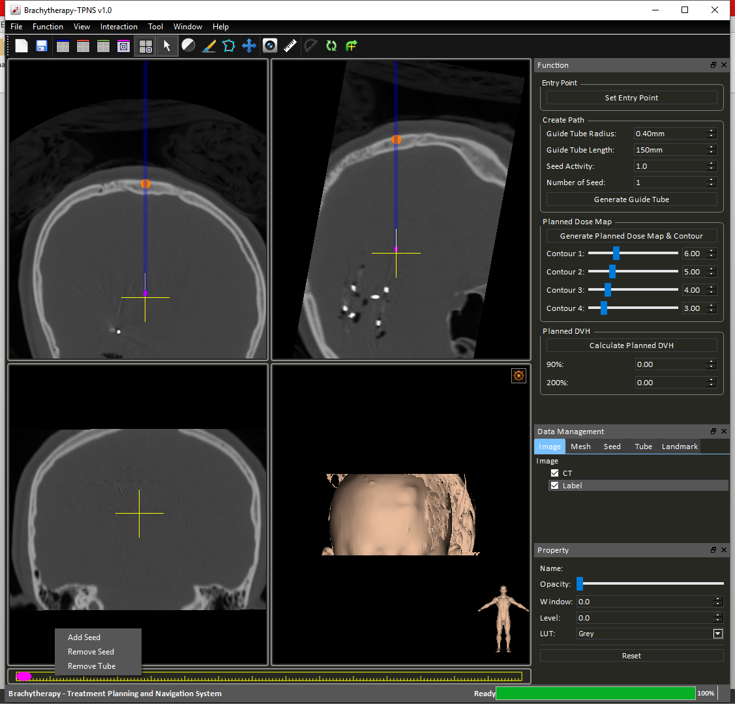

Figure 17 Guide tube control widget

By dragging the location of the purple seeds within the selected guide tube, user can determine the location of the seeds relative to the tube.

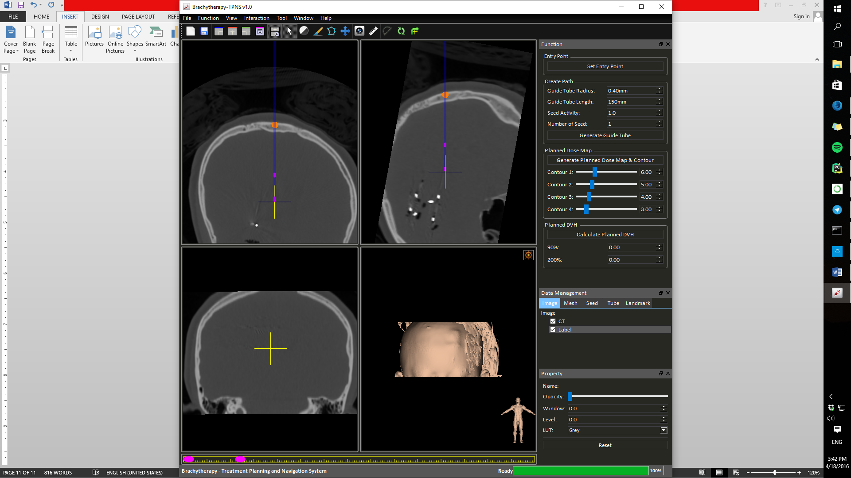

Figure 18 Moving Seeds

Repeat **Step 3** to create more guide tubes. Note that there are no restriction to the plane normal of seeds placing.

#### Dosemap and Contour Generation

A dosemap of the current seed configuration can be generated by clicking the “Generate Planned Dose Map & Contour” button (Figure 19).



Figure 19 Generate Planned Dose Map & Contour

The contour based on the assigned values will also be generated and displayed in the view ports (Figure 20).

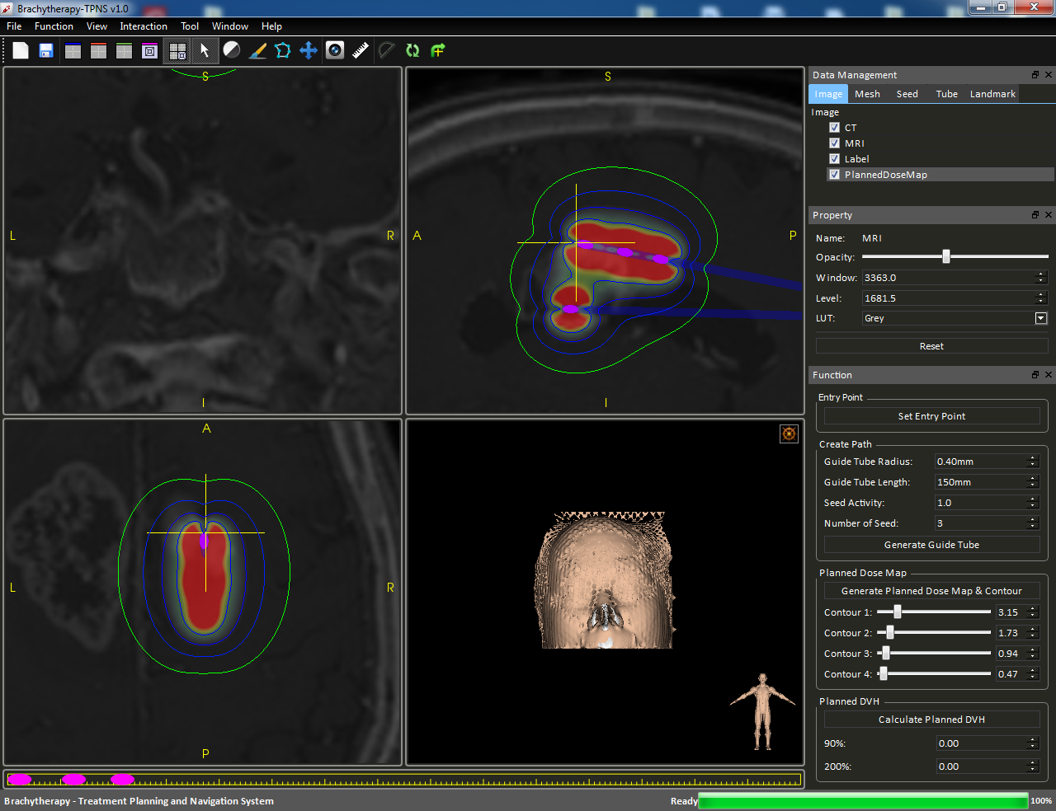

Figure 20 Dosemap with contour

Use can click on the “Show Contour” check box in Figure 19 to toggle the contour for faster interactions.

#### Dose Volume Histogram (DVH)

After segmentation and generation of dosemap, a DVH can be produced by pressing the “Calculate Planned DVH” button.

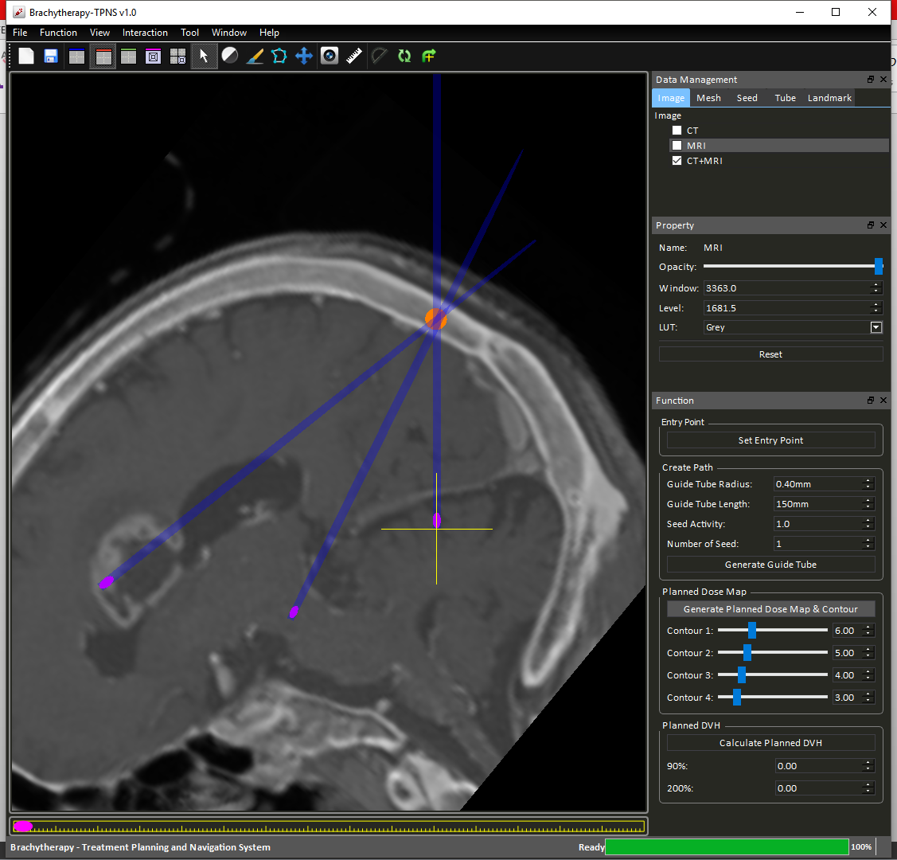

Figure 21 Calculate Planned DVH

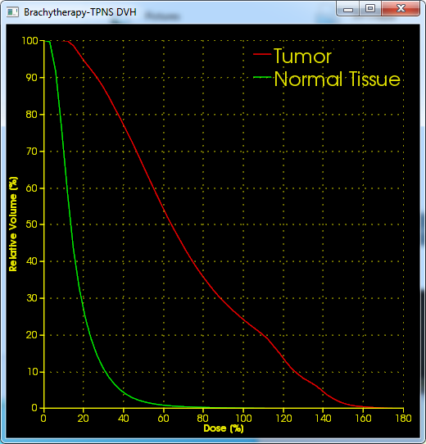

Figure 22 DVH illustration

#### Cast Building

A surgical guiding cast can be generated by selecting “Cast Build” option under the “Function” tab (Figure 23).

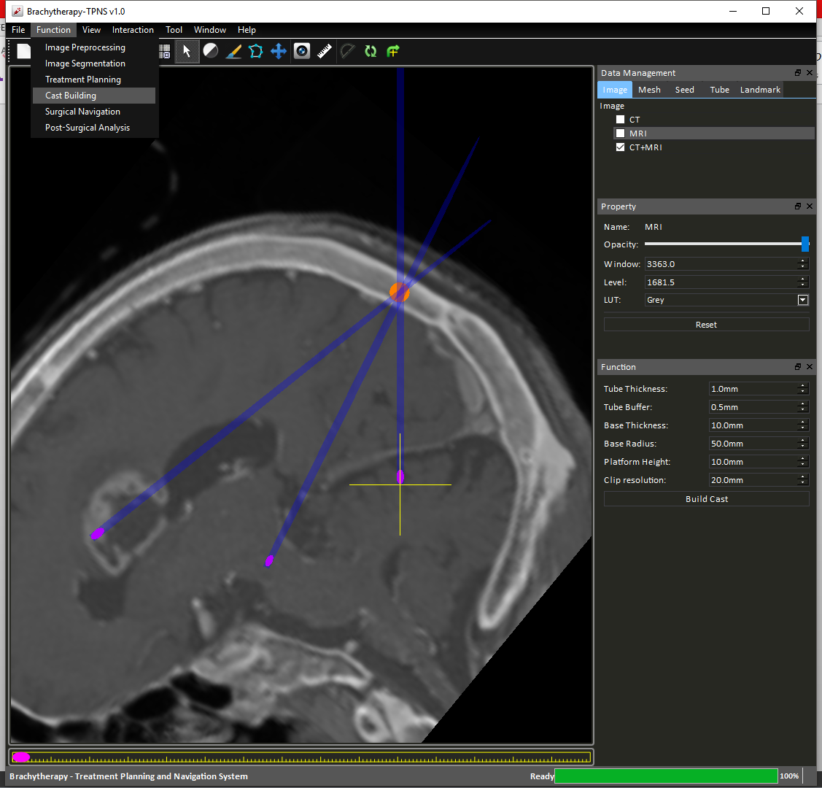

Figure 23 Function tab options - Cast Building

Then press the “Build Cast” button on the panel (**Figure 24**).



Figure 24 Build Cast Properties

A cast will then be automatically built (Figure 25), if error comes up, adjust the property of the cast according to the error message.

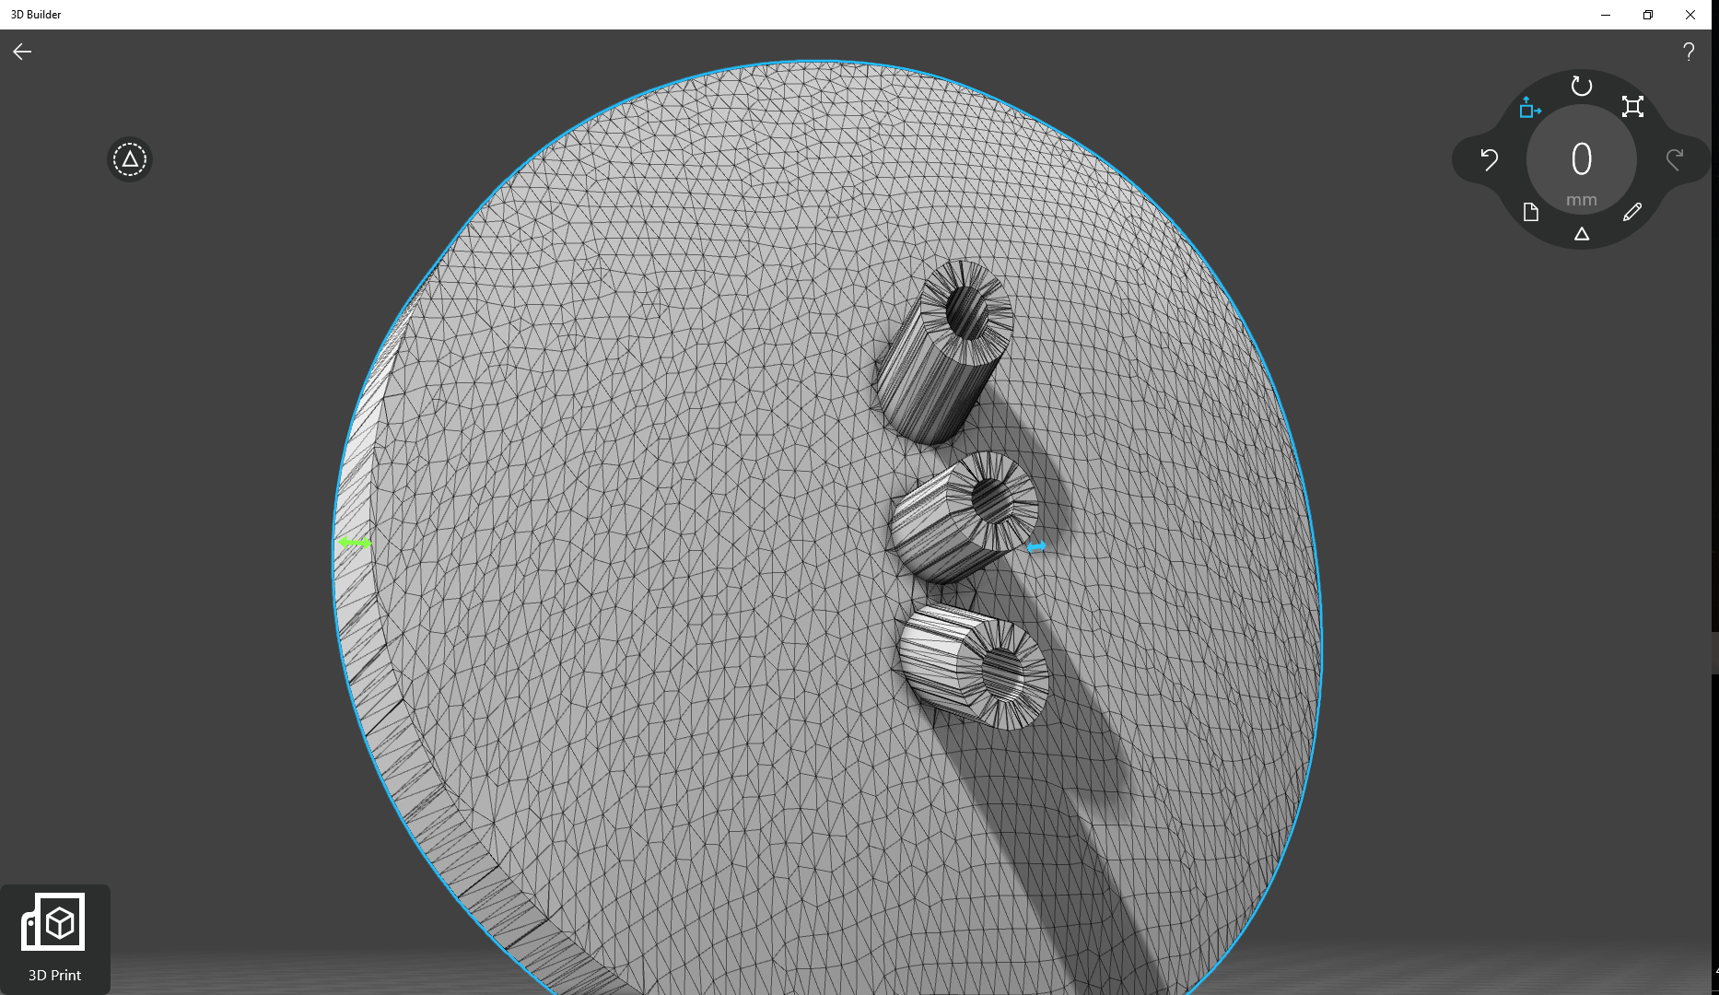

Figure 25 Cast Mesh Product

To export the cast as STL file, simply right click on the mesh desired in the “Data Management Panel” and select “Export Mesh” (Figure 26).

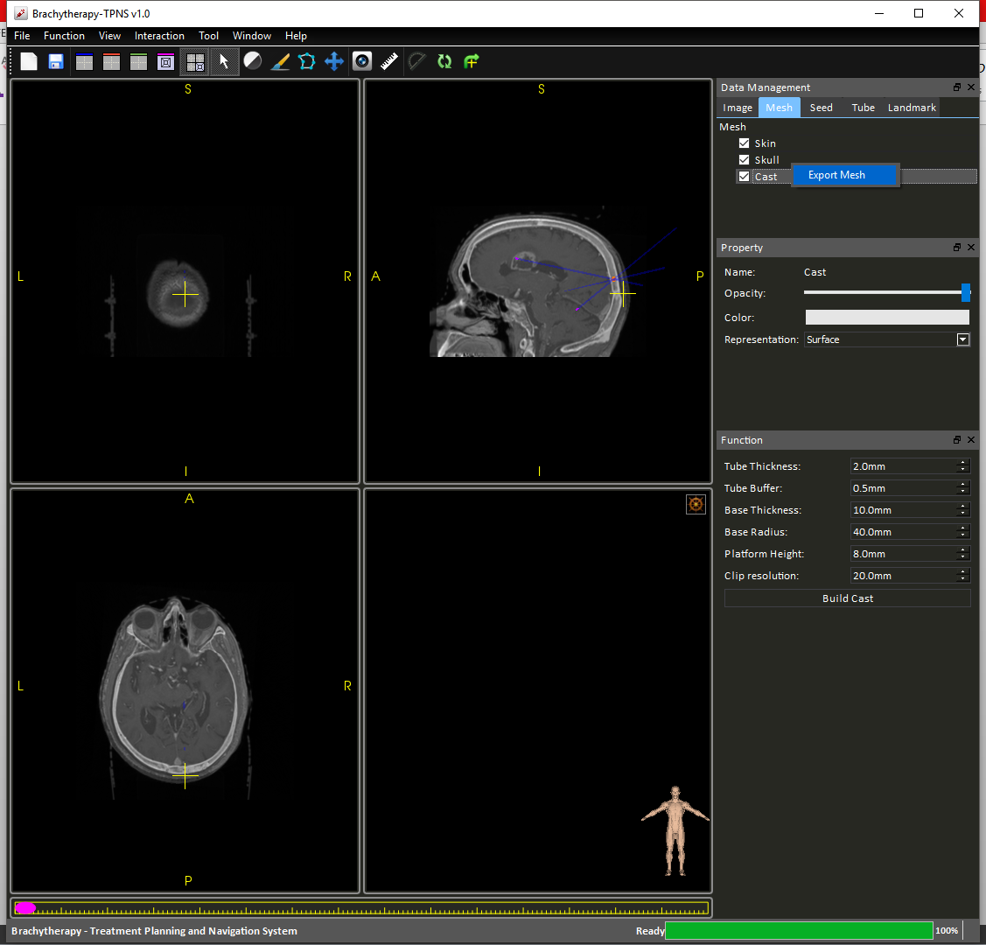

Figure 26 Export Mesh

#### Marker Holes Generation

Holes can be added to the cast for aligning cast with pre-defined markers. In the same “Cast Build” option under “Functions” tab (Figure 23), there is an “Advance” panel (Figure 27).

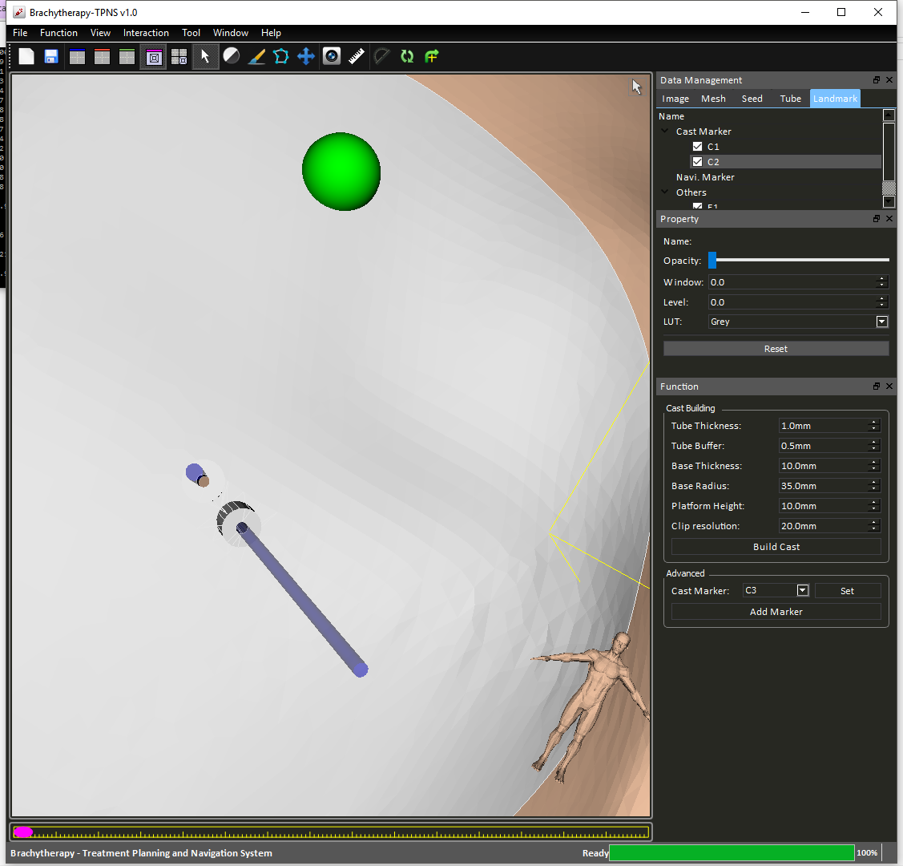

Figure 27 Advance marker options

User can pin point the location in “View” mode, select cast marker labels “C1”, “C2” ... and then press “Set” to set a marker for holes punching. The marker appears as a green sphere in the 3D view port (Figure 28).

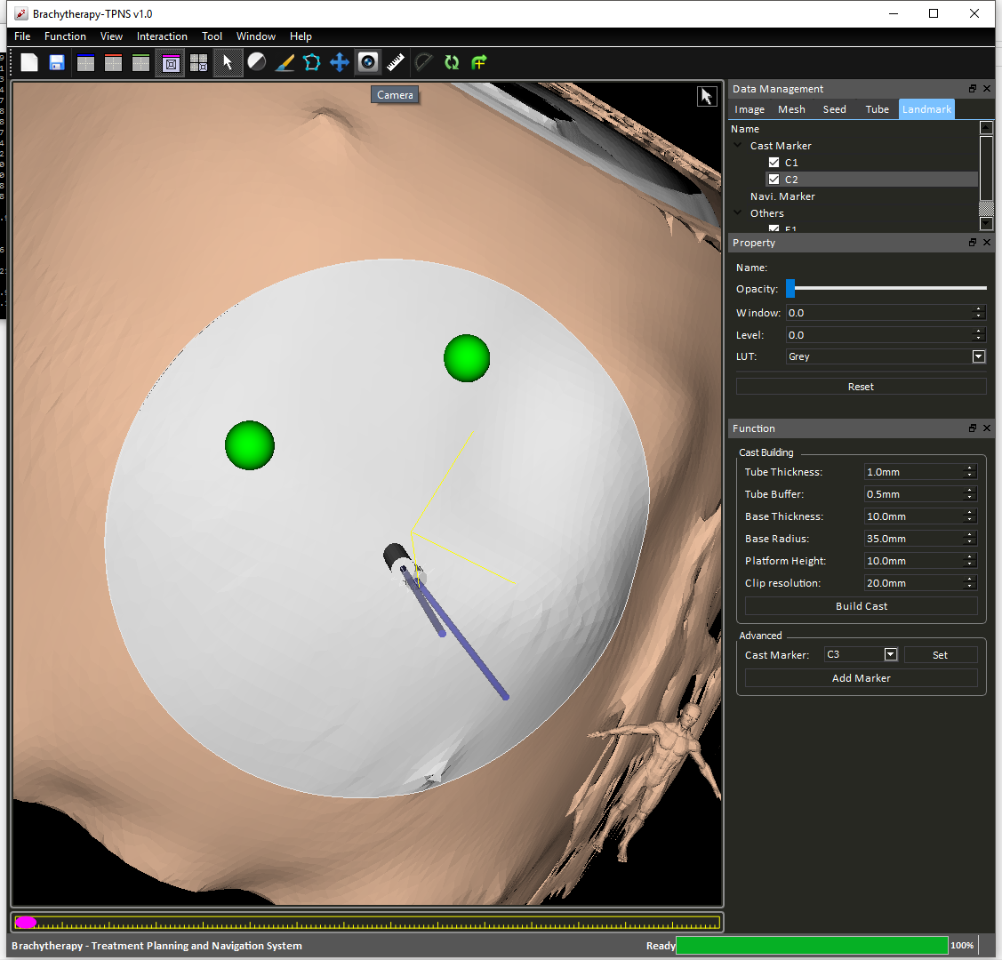

Figure 28 Holes punching

Once holes configuration is done, press the “Add Marker” button in the right-hand-side-panel. A mesh with holes will be generate with the name “MarkedCast” (Figure 29).

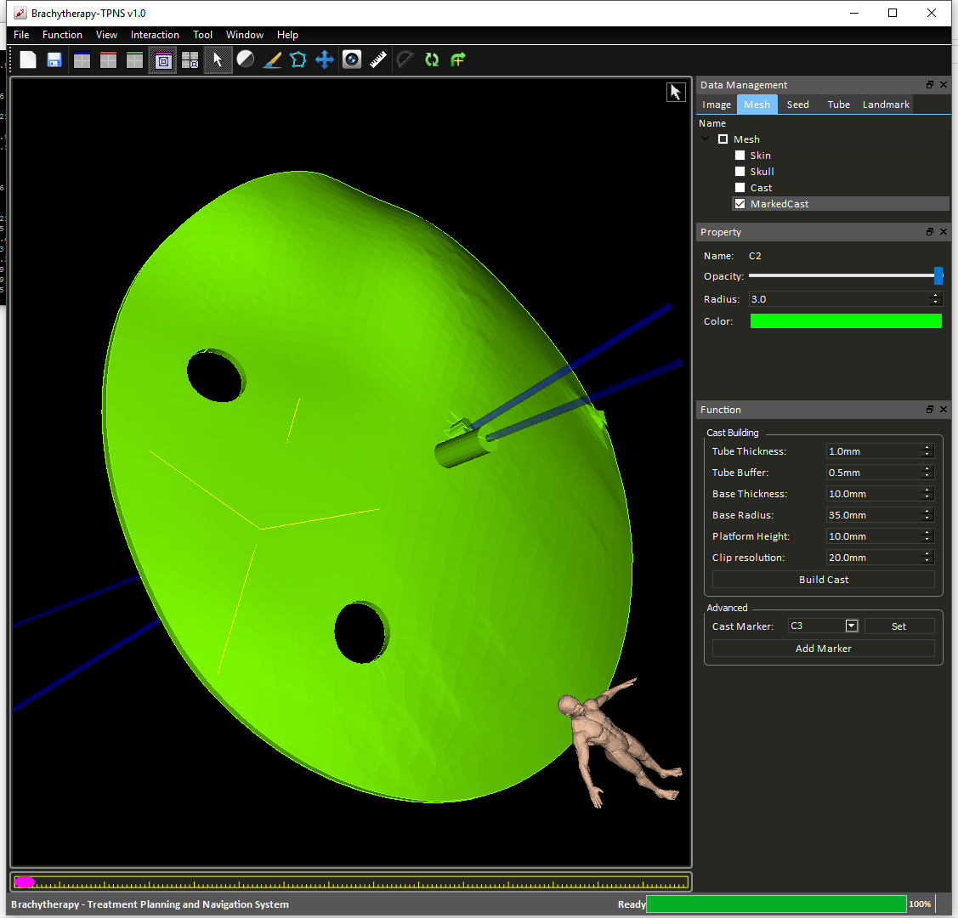

Figure 29 Marked Cast Mesh

### Post-surgical Analysis

Post-surgery analysis can be performed by clicking the “Post-Surgical Analysis” option under the “Functions” tab.

User would have to provide a post-surgical CT image first by clicking “Add Intra CT Image” button (Figure 30) and select the corresponding image from their own database.

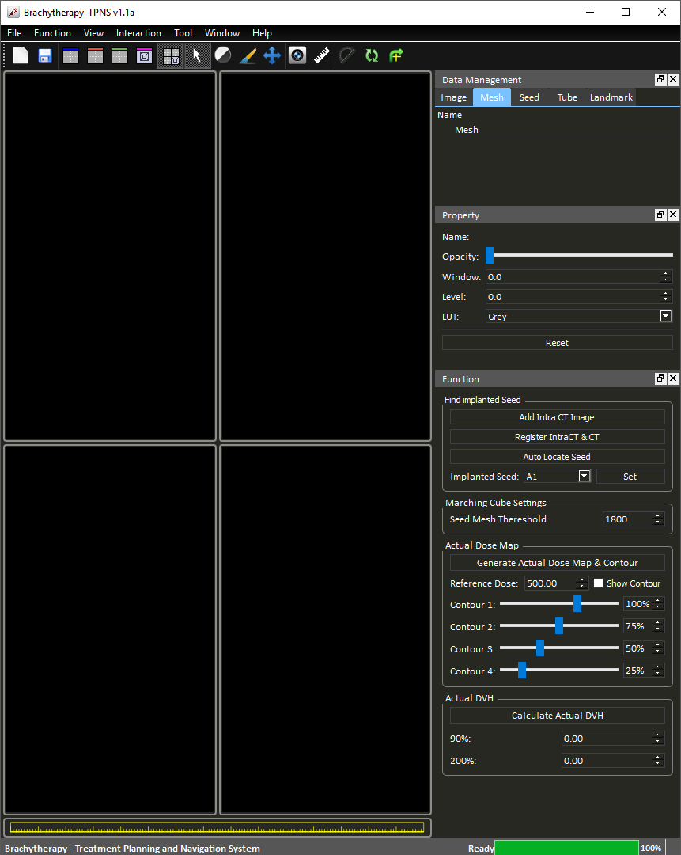

Figure 30 Post-Surgical Analysis Panel

A short cut button is provide here for user to register the “IntraCT” image to the “CT” image, multiple registration can be performed until the result is satisfactory. Other components of this function is essentially the same as the “Treatment Planning” function.

A marching cube is performed to generate a 3D mesh for the seeds as shown below (Figure 31), the threshold can be adjust to get rid of unwanted mesh:

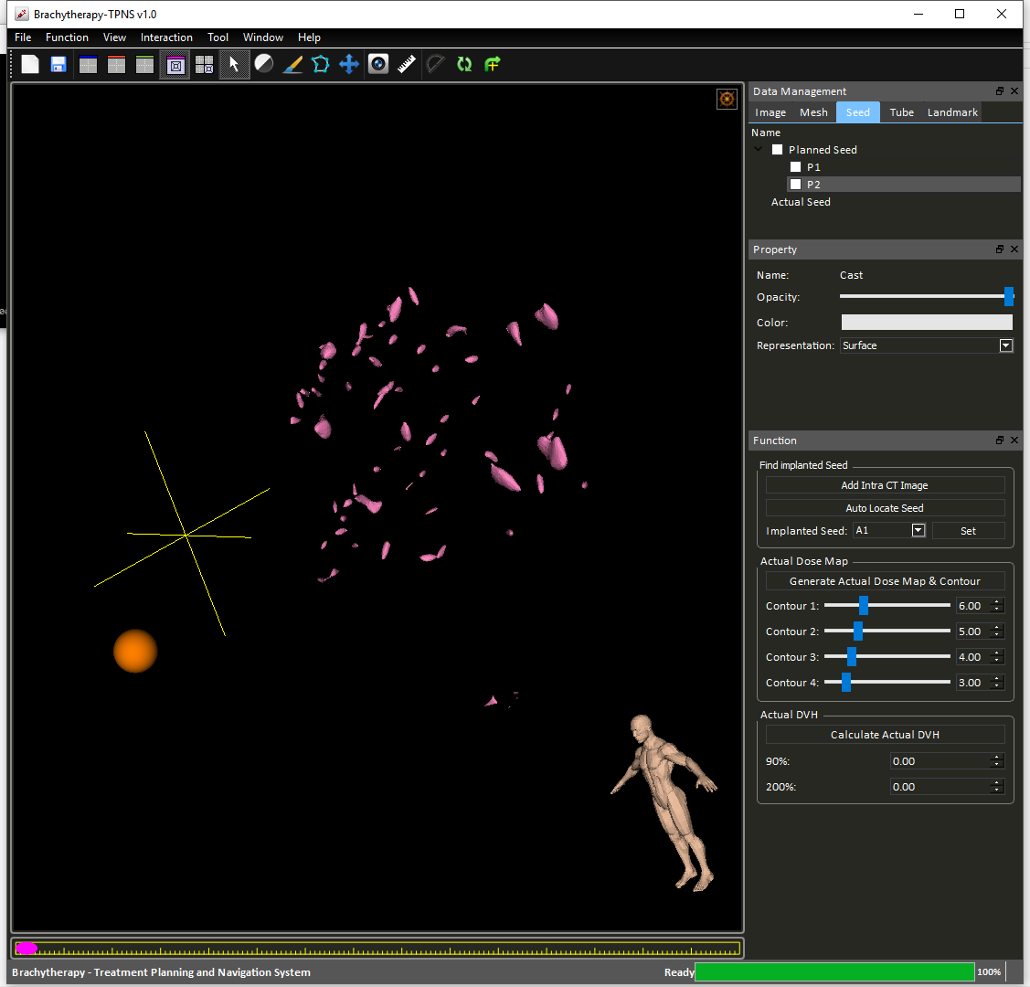

Figure 31 Seed 3D mesh

Then press “Auto Locate Seed” button to approximate seeds’ locations and orientations (Figure 32).

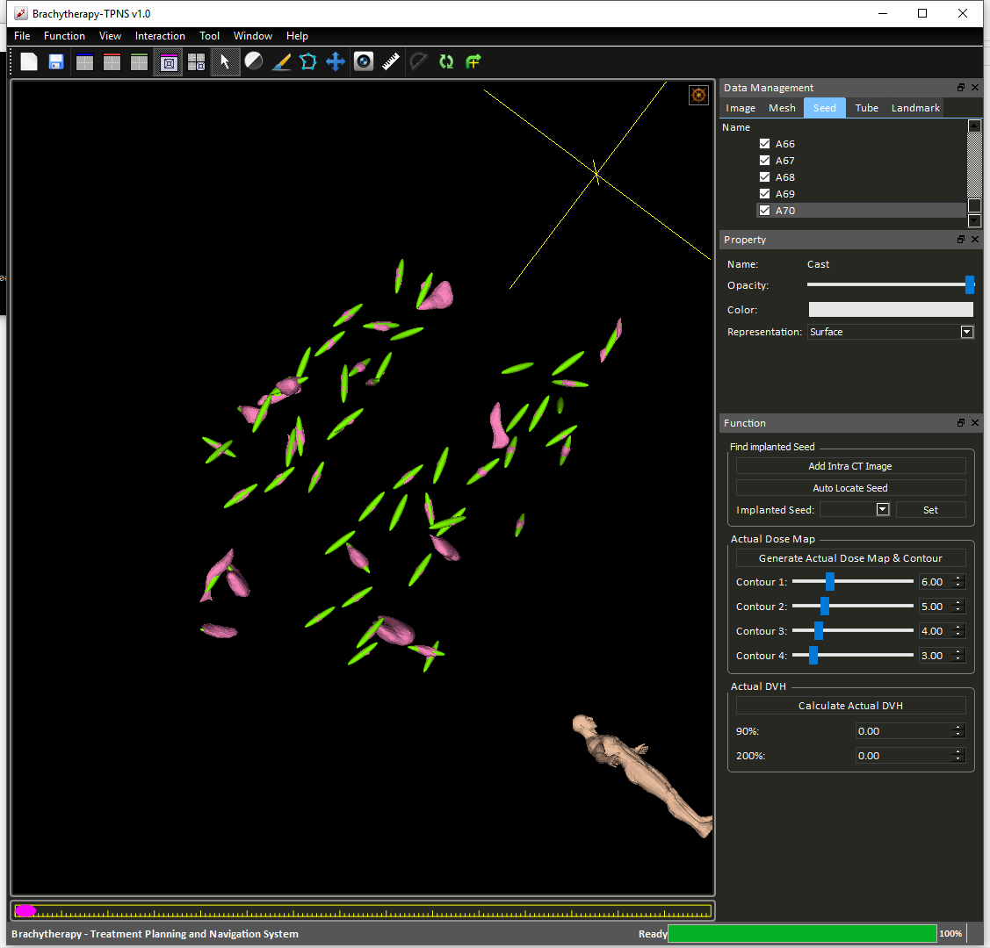

Figure 32 Auto locate Seeds

However, the located seeds can be adjusted by switch to “Seed Adjusting” mode (Figure 33) through clicking the button at the upper right corner of the 3D view port.

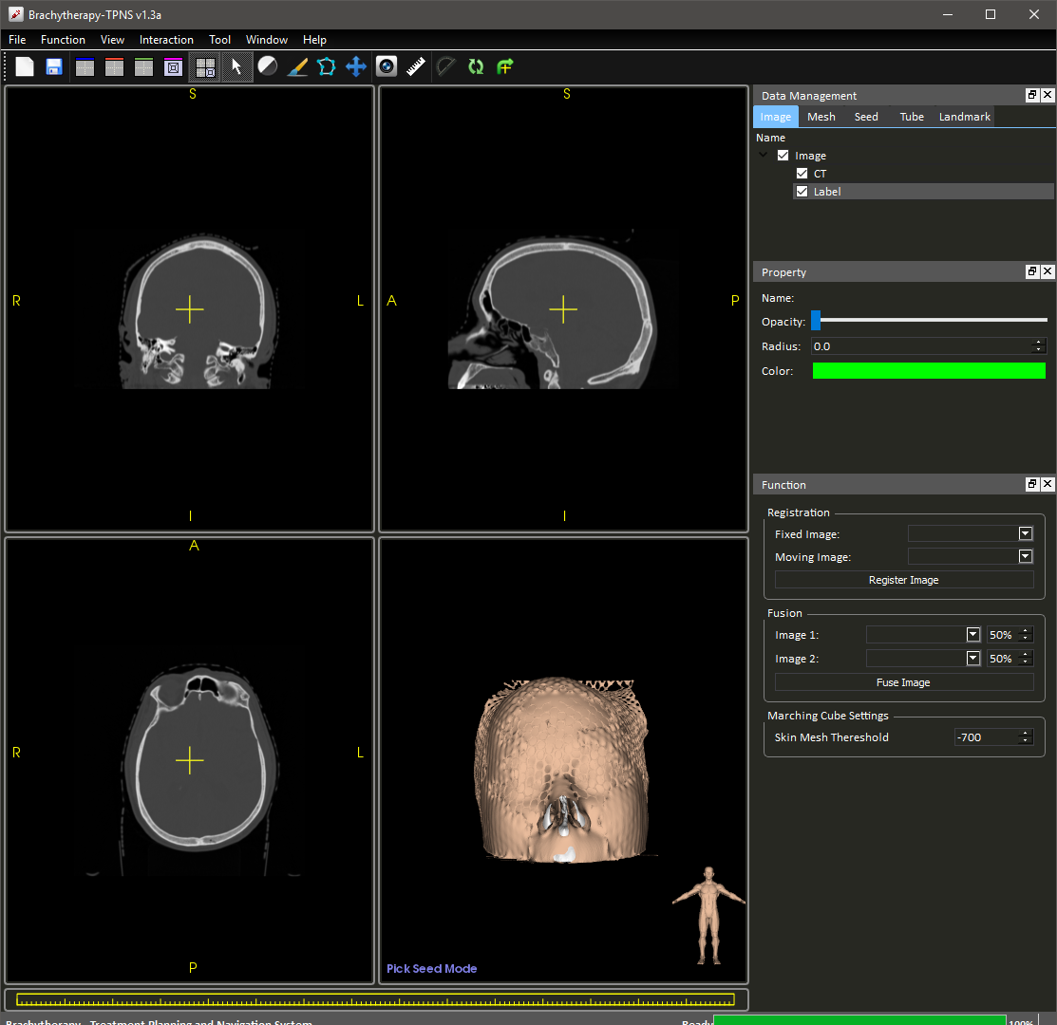

Figure 33 Seed Adjusting mode

In this mode, you can interact with seeds in 3D view port. Hover on the target seed and see it changes color:

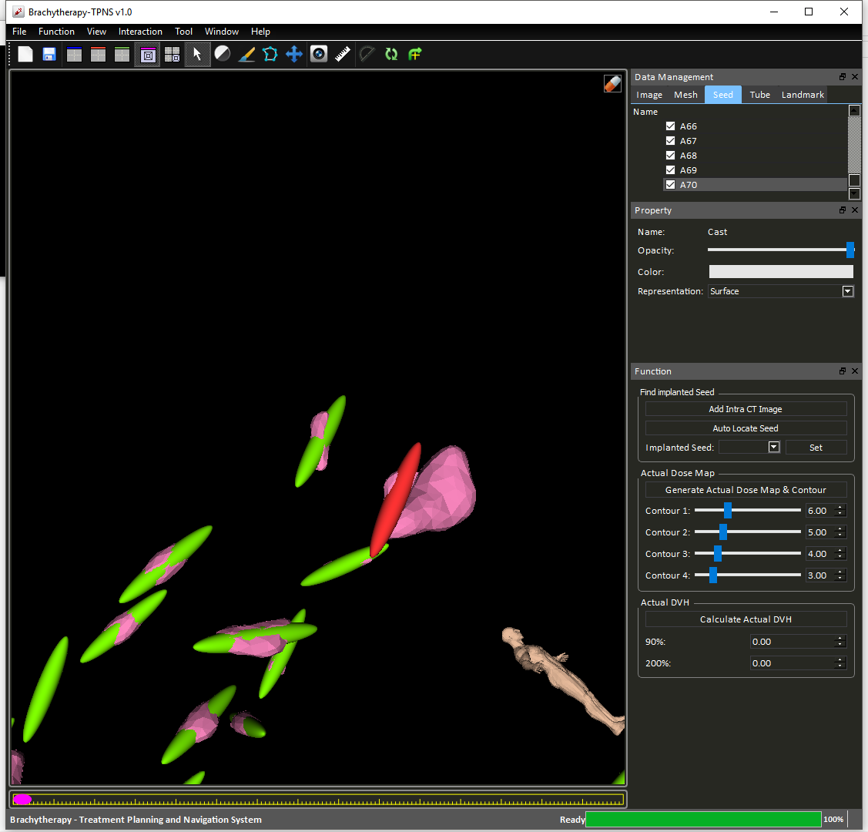

Figure 34 Selecting Seed

The red seeds shows that it is selected. Users can then perform one of the followings actions:

|  |  |
| --- | --- |
| **Actions** | **Functions** |
| Left | Rotate the seed. |
| Crtl + Left | Rotate the seed about the view axis. |
| Shift + Left | Move seed in the plane of display. |
| Middle | Same as Shift + Left. |
| Ctrl + Middle | Move seed in or out of the monitor. |
| Delete | Remove seed from list |
| n | Add new seed at the anchor position (yellow cross) |

## Known Issues

Some cast configuration require further mesh repair before 3D printing.

## Credits

**Prof. Wang, De Feng**

*Assistant Professor, Dept. Image and Interventional Radiology,*

*The Chinese University of Hong Kong*

**Mr. Lok, Ka Hei**

*Mphil. Student, Dept. Image and Interventional Radiology,*

*The Chinese University of Hong Kong*

**Mr. Ko, Jacky**

*Mphil. Student, Dept. Image and Interventional Radiology,*

*The Chinese University of Hong Kong*

**Mr. Wong, Matthew Lun**

*Junior Research Assistant, Dept. Image and Interventional Radiology,*

*The Chinese University of Hong Kong*